AGSW Event Thursday, January 18, 2018 Comedy & DJ Dance Party

Comedy Portion of the Night
Produced by Bob King of RLK Productions Inc.

Where: Belly Up Aspen
When: 9-10:30pm
Who: Julie Goldman & Justin Sayre
What: Comedy show featuring two stand-up comedians
Ticket Pricing: $45 GA, $65 Reserved
Budget $15,500

Budget Breakdown:
Expense
- Fee to RLK Production Inc. for talent $12,000 ½ to be paid as deposit ½ to be paid day of event.
- $2000 for hotel accommodation at the Hotel Jerome, 2 nights for 2 ppl, 4 nights total.
- Airfare paid to RLK Productions Inc. not to exceed $1000 for all
- $250 allocated for dinner night of the event for RLK Productions & comics.
- $1,500 to RLK Productions Inc. if event sells out (negotiable so as not to go over the budget).
- RLK Productions Inc. to receive 2 Black Diamond Passes
Revenue
- 200 GA Tickets at $45 = $9,000
- 40 Reserved Tickets at $65 = $2,600
- 150 Pass holders including Black Diamond, Patron, Patron XL & Sponsors. Does not include Blind date Passes and may not include Black Diamond, tbb

Julie Goldman – Need Bio
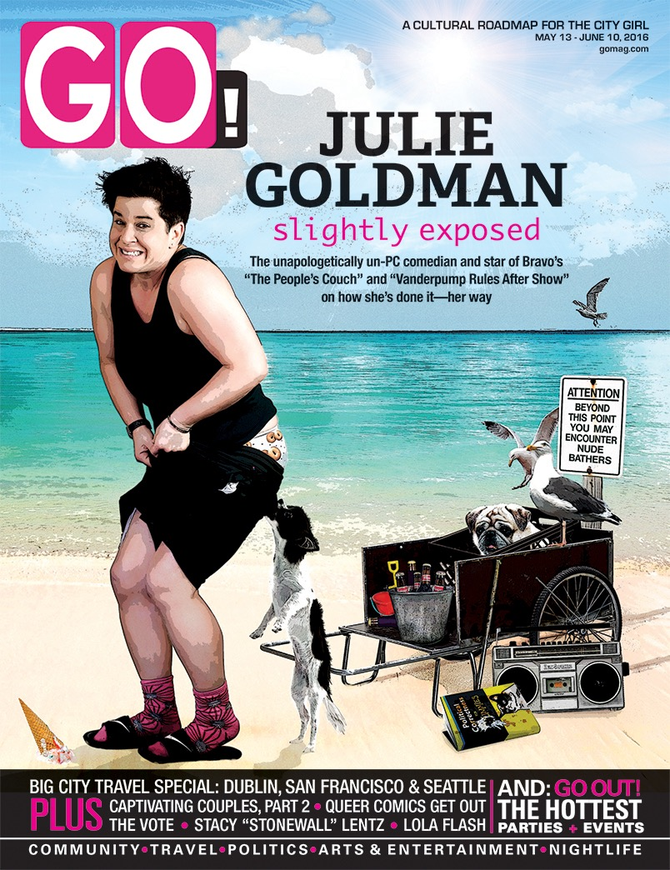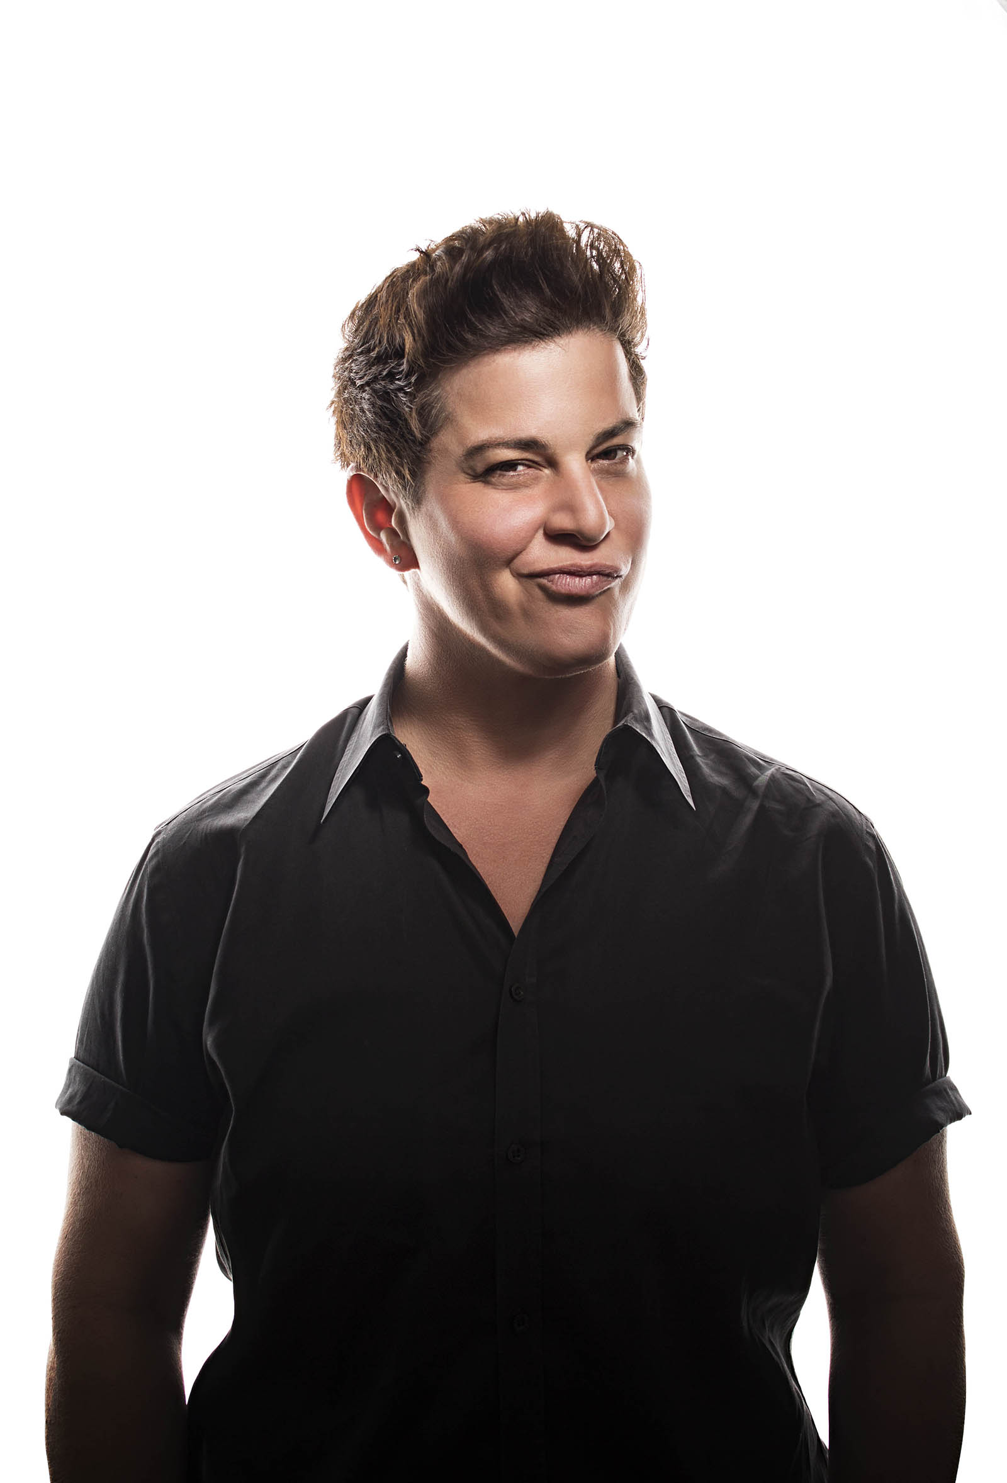

Justin Sayre
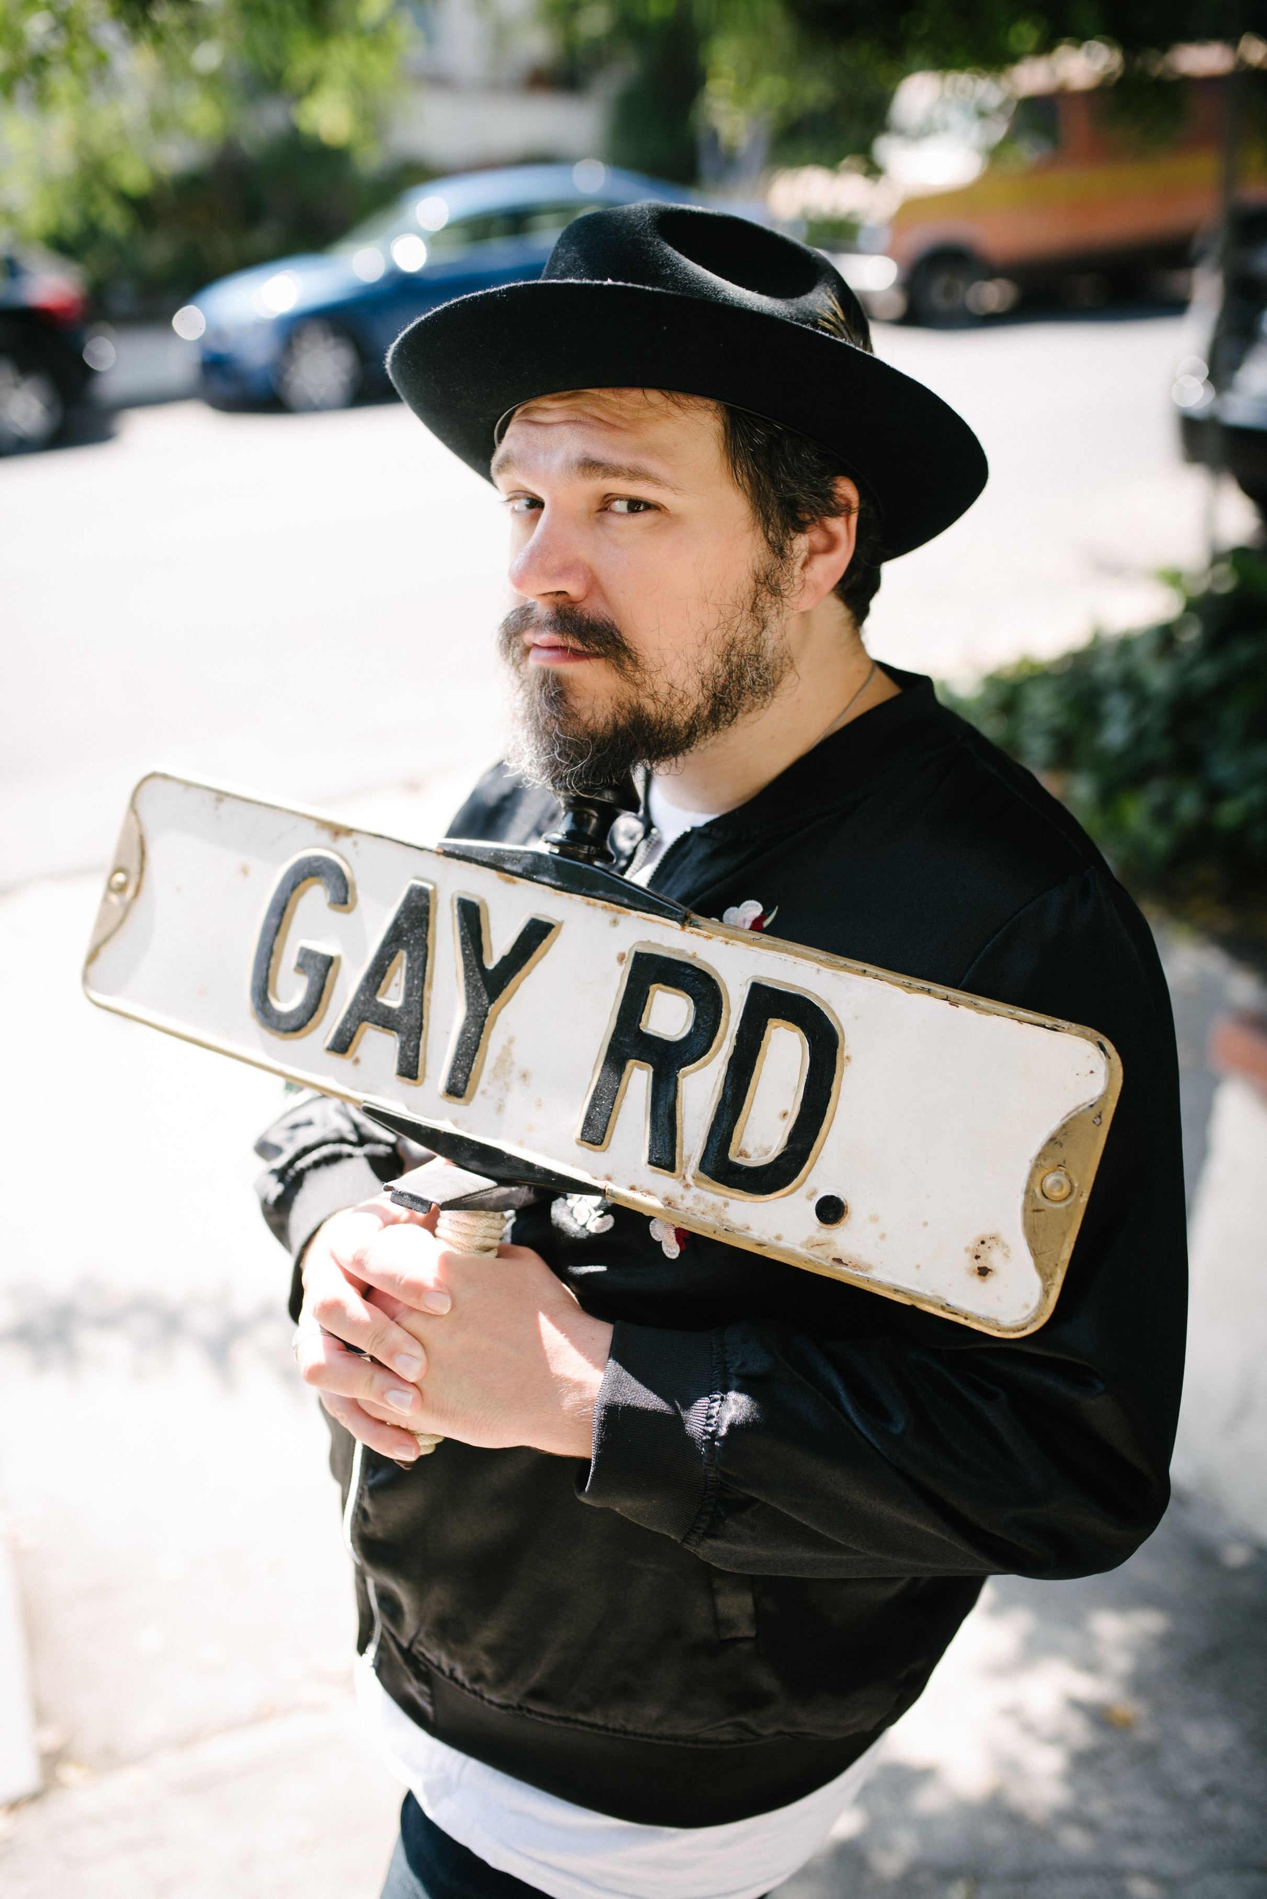
Justin Sayre is a writer, performer, and podcaster best known for his downtown cabaret/variety show The Meeting*, which ran for eight successful seasons. Sayre's debut comedy album, "The Gay Agenda," was called one of 2016's "Best Things in Comedy" by The Comedy Bureau. Their original works for the theater have been shown at La MaMa, Dixon Place, The Wild Project, Queer Pop-Up Museum, Ars Nova, and The Players Club. Sayre also hosts an iTunes podcast, SPARKLE & CIRCULATE, where they interview performers, writers, and other creative minds of the community. As an activist, Justin's charity benefit show, "Night of a Thousand Judys," raises money for the Ali Forney Center for Homeless LGBT youth and is now in its 7th year. Their debut children's novel, Husky, was deemed "a superb addition to the middle grade literary cannon" by VOYA Magazine. In July 2017, Sayre released his second children's novel, Pretty, which Publishers Weekly praised as "[a] powerful story of growth and change, brimming with honesty and hope." Additionally, Sayre wrote for CBS' hit comedy series, 2 Broke Girls, and has appeared in Lisa Kudrow's The Comeback on HBO.

DJ Dance Party Directly Following Comedy Event
Where: Belly Up Aspen
When: 10:30pm – 2:00am
Who: Guy Scheiman
What: International DJ Dance Party
Ticket Pricing: $45 GA
Budget $2,700

Expense
- $1,500 fee to Dj
- $1,200 3 hotel nights
- 2 event passes
- DJ to arrange own travel from Tel Aviv
Revenue
- Included in all Passes
- 100 GA tickets at $40 = $4,000

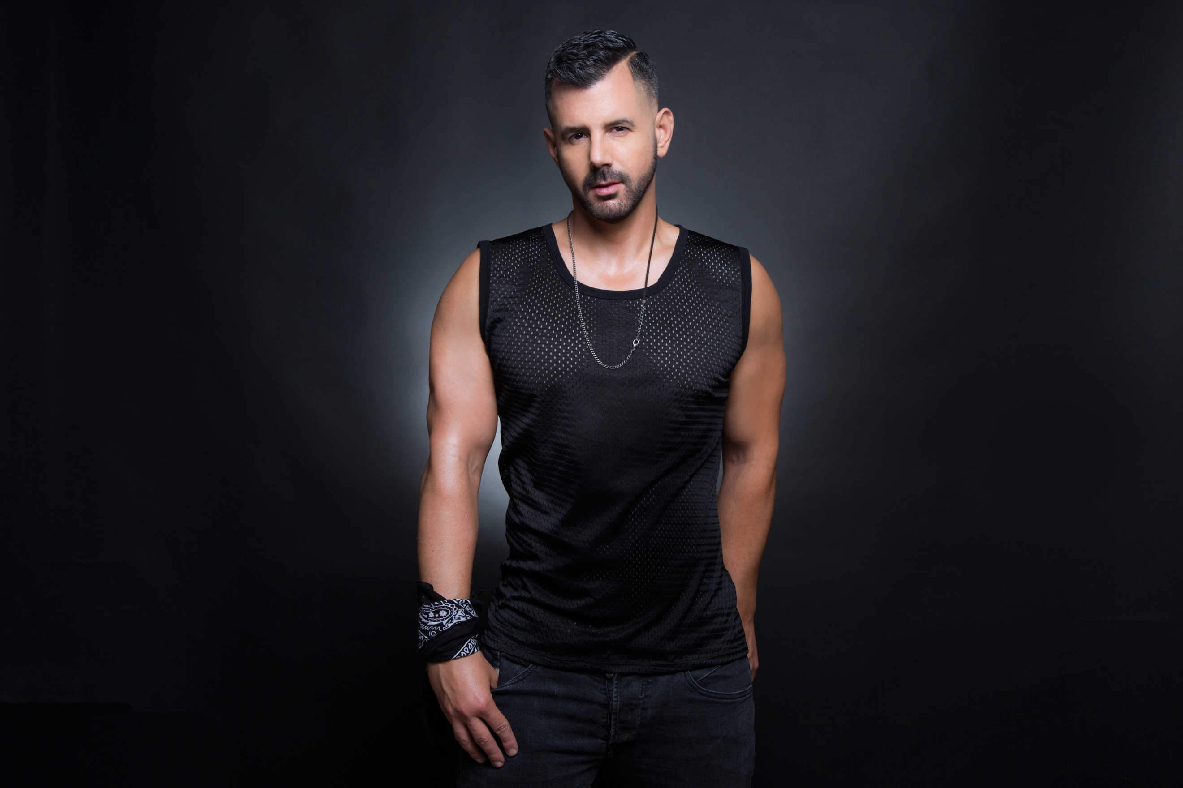
Come dance late night after comedy with Tel Aviv based DJ/Producer, Guy Scheiman and owner of "Guy Scheiman Music" record label. Guy Scheiman is known for his high-energy sound that combines house, progressive, tribal and tech house with strong melodies and memorable vocals. His live sets are all about energy beats, combining old and new school vocals that ignite his dance floors and create euphoric experiences. His official remixes and original productions stand out as massive club anthems with big bass line, driving grooves, passionate melodies and memorable breaks.

http://www.guyscheiman.com

https://soundcloud.com/guyscheiman_mixes_sets/halloween-2017-mixed-by-guy-scheiman
BIO
“Music is food for the soul; it’s a wonderful getaway from our daily life. It has a key role in making our life brighter. For me, what is the most important is to make people happy with my music. It’s an art form and when I see my work being appreciated by a crowd it means the world to me. I hope I can keep people happy through my music for many years to come”

Official Remixes
JLo
Six-time Grammy Award Winner Amy Grant
Cher – reaching #2 on Billboard
Kylie Minogue
Lady Gaga
Rihanna
Scissor Sisters
Ellie Goulding
Flo Rida feat Sia
Kristine W
Ciara
Doxi Jones
NiRé AllDai
Blake Lewis
Martha Wash
Ultra Nate

• 10 #1 Billboard HIts
• 20 US Billboard Top 10 Hits.

Over the past decade, Scheiman has amassed an impressive roster of club appearances and major headlining events that span 3 continents. He’s played some of the biggest parties and clubs in Europe and the Middle East – including Oman 17 (TLV), Kluster (Madrid Main Pride Event), Salvation, HustlaBall (London), Black Party (Zurich), Scream (Paris), , Hunket (Brussels), Glam (Nice), Pulse (Hamburg), OMG (Prague), Bear Necessity (Amsterdam Pride) , and Red & Blue (Antwerp).
Outside Europe, Scheiman has toured extensively in the United States, Brazil, Mexico and China – where he headlined parties as Revolution In Rio (NYE & Carnival) , G – Music Fest in Mexico City and Icon Shanghai. In the U.S Scheiman headlined Jeffrey Sanker’s White Party Palm Springs and debuted his DJ skills in Canada for Fly Toronto, along with Beijing , Shanghai and Seoul. Guy Scheiman is global!
In 2015 Scheiman released his own label "Guy Scheiman Music" with hot originals and remixes that are hitting the dance and billboard charts across the globe.

Top DJs around the world have supported Scheiman’s production work and regularly include his remixes in their live sets. These include: Funkagenda, Jonathan Ulysses, Miss Nine, Roger Sanchez, Sarah Main, The Flash Brothers, Thomas Penton, Tony English, Dave Aude, Erick Decks, Danny Verde, Ivan Gomez, Ivan Pica, Jens Lissat, Abel, Chris Cox, Paulo, Steve Pitron, among others.

With a growing roster of major bookings in Asia and the Americans already planned for next year, plus more exciting remix and original production work on the way, Scheiman will continue to make his mark on the dance music scene and draw thousands of fans to his events from now into 2017.

